



**Master Thesis**

**Investigating image properties that cause visual discomfort**

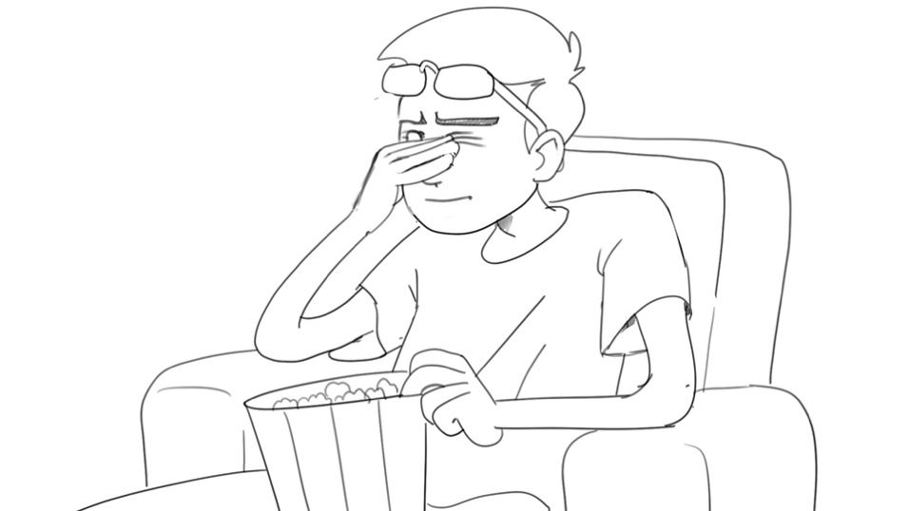

# Project Description

When watching a movie or looking at images, some people experience what’s called ***visual discomfort*** — they find the content on the screen to be uncomfortable or even painful to watch. Typical symptoms of visual discomfort include headaches, nausea, and fatigue. Image properties that can lead to discomfort include flashes, static patterns, saturated color and movement.  Previous research has modeled how some of these image properties relate to visual discomfort.  However, there is currently no automatic method of detecting potentially uncomfortable image or video content.  The aim of this thesis is to implement and refine algorithms for detection of visually uncomfortable content, building on previous research.  This may also involve validation by collecting and analyzing additional behavioral data.  The goal is to develop a tool that can help filmmakers assess which part of an image may cause visual discomfort, helping to make movies more enjoyable to watch for diverse audiences.

# Skills

* Good knowledge of image and video processing techniques
* Interest in visual perception

# Remarks

A written report and an oral presentation conclude the thesis. The thesis will be overseen by Prof. Robert W. Sumner or Prof. Markus Gross, and Steven Poulakos (DRS). Please contact Steven Poulakos ([steven.poulakos@disneyresearch.com](mailto:steven.poulakos@disneyresearch.com)) for more information.